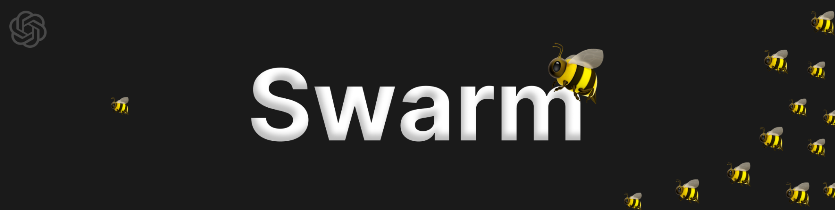

What even is an Agent Framework?
- Simply put, a framework makes building AI Agents easier & faster.
- With OpenAI Swarm, you can have AI Agents delegate tasks to one another.
- It’s built on top of OpenAI Chat Completions API, so the syntax will be very familiar.

OpenAI Swarm 🐝 - Multi-Agent Orchestration Framework

OpenAI Swarm is a practical multi-agent orchestration framework that lets you deploy, manage, and scale specialized AI agents working together to handle complex workflows. In this demo, a central Orchestrator Agent intelligently assigns tasks to two Worker Agents:
- Natural Language to SQL Agent: Translates plain language commands into SQL queries.
- Email Agent: Composes and sends emails based on custom user inputs.

What is Swarm?

Swarm is OpenAI’s innovative approach to creating a flexible and efficient framework for orchestrating multiple AI agents. Described as an ergonomic, lightweight, multi-agent orchestration framework, Swarm is currently in its experimental phase, aiming to explore user-friendly interfaces for managing complex multi-agent systems.

Key Features of Swarm
- Agents and Handoffs:
  - Core abstractions in Swarm.
  - Agents: Perform tasks.
  - Handoffs: Facilitate task coordination between agents.
- Routines:
  - Predefined instructions that guide agents to complete specific tasks.
- Lightweight and Controllable:
  - Efficient agent coordination and task execution for optimized performance.
- Open Source and MIT Licensed:
  - Fully open source under the MIT license.
  - Developers can experiment, modify, and integrate easily.

- Familiar Interface:
  - Resembles the Chat Completions API for intuitive use by developers familiar with OpenAI’s tools.

How Swarm Stands Out
While there are other multi-agent frameworks available, such as Hugging Face’s Transformers Agents 2.0, Swarm distinguishes itself through its simplicity and minimalist design. Unlike more complex frameworks that may come with a steep learning curve, Swarm offers a clean implementation with just two main abstractions: agents and handoffs.

Orchestrating Agents: Routines and Handoffs

1. What are Routines?
Routines in Swarm are essentially predefined sets of instructions that an agent follows to accomplish a specific task.

Key Characteristics of Routines:

– Structured Steps: Routines consist of a sequence of steps or actions that guide the agent’s behavior.
– Tools Integration: They leverage specific functions (tools) that the agent can execute to perform tasks.
– Conditional Logic: Routines can include conditions that determine which path the agent should take based on user responses or other factors.

Example: Customer Service Routine
Imagine you have a customer service agent for an online store. The routine for handling a refund request might look like this:
1. Greet the Customer: Start the conversation politely.
2. Understand the Issue: Ask probing questions to grasp the reason for the refund.
3. Propose a Solution: Offer a fix or replacement if applicable.
4. Offer a Refund: If the customer is still unsatisfied, proceed with the refund process.
Code Representation:

system_message = (

"You are a customer support agent for ACME Inc."

"Always answer in a sentence or less."

"Follow the following routine with the user:"

"1. First, ask probing questions and understand the user's problem deeper.\n"

" - unless the user has already provided a reason.\n"

"2. Propose a fix (make one up).\n"

"3. ONLY if not satisfied, offer a refund.\n"

"4. If accepted, search for the ID and then execute a refund."

)

def look_up_item(search_query):

return "item_132612938"

def execute_refund(item_id, reason="not provided"):

print("Summary:", item_id, reason)

return "success"


2. What are Handoffs?
Handoffs refer to the process of transferring control from one agent to another within the Swarm framework. This is akin to transferring a phone call from a receptionist to a specific department based on the caller’s needs.

Key Characteristics of Handoffs in Swarm:
- Specialization:
  - Different agents are designed to specialize in handling specific types of tasks or inquiries.
- Seamless Transfer:
  - Handoffs maintain smooth conversation flow, transferring interactions between agents without losing context.
- Dynamic Control:
  - Agents dynamically decide when and to whom to hand off conversations based on the interaction context.

Example: Triage Agent and Specialized Agents
Let’s consider a scenario with a triage agent that directs customer queries to either a sales agent or a refund agent based on the user’s request.

class Agent(BaseModel):

name: str = "Agent"

model: str = "gpt-4o-mini"

instructions: str = "You are a helpful Agent"

tools: list = []

def transfer_to_refunds():

return refund_agent

def transfer_to_sales_agent():

return sales_agent

triage_agent = Agent(

name="Triage Agent",

instructions=(

"You are a customer service bot for ACME Inc. "

"Introduce yourself. Always be very brief. "

"Gather information to direct the customer to the right department. "

"But make your questions subtle and natural."

),

tools=[transfer_to_sales_agent, transfer_to_refunds],

)


How Routines and Handoffs Work Together in Swarm:
1. Initiation:
- The user starts interacting with an initial agent, such as a triage agent.
2. Routine Execution:
- The agent follows a routine, leveraging tools and predefined steps to manage the interaction.
3. Decision Point:
- The agent determines whether to continue handling the interaction or transfer it to a specialized agent based on user needs.
4. Handoff:
- If necessary, the current agent seamlessly transfers control to another agent better suited for the specific task.

Example Interaction Flow:
- User: “I want to place an order for a black boot.”
- Triage Agent: Recognizes the request as a sales-related inquiry.
- Handoff: Transfers conversation to the Sales Agent.
- Sales Agent: Assists the user in completing the purchase.
- User: “Actually, I want a refund.”
- Sales Agent: Transfers back to the Refund Agent.
- Refund Agent: Handles the refund request efficiently.

Code Representation:

agent = triage_agent

messages = []

while True:

user = input("User: ")

messages.append({"role": "user", "content": user})

response = run_full_turn(agent, messages)

agent = response.agent

messages.extend(response.messages)


Getting Started with Swarm
Setting up Swarm is straightforward, thanks to its well-documented repository. Here’s a quick overview of how to set up a basic multi-agent system using Swarm:

1. Import the Swarm Library:
import swarm
from swarm import Agent

2. Initialize Swarm:
swarm.init()

3. Define Agents and Routines:
Create agents by specifying their name, system instructions, and the functions they can execute.

agent_a = Agent(

name="Agent A",

instructions="Handles English conversations.",

tools=["transfer_to_agent_b"]

)

agent_b = Agent(

name="Agent B",

instructions="Handles Spanish conversations."

)


4. Execute and Manage Handoffs:
Use function calls to transfer control between agents based on the conversation’s context.

response = agent_a.handle_message(user_input)

if needs_spanish:

response = agent_a.transfer_to_agent_b(user_input)


